Medicine Plant Retreat at
Tierra Nuna Ayni Center
April – May 2021

Program
This program has been designed with the purpose of healing. This is a very delicate process for what we ask you to read it carefully and send your application form (that you will find at the end of all the information) to luzmaria@nunaayni.org.pe for the corresponding approval. You will need to first be approved by her before sending your deposit. For more information about it, confirmation and deposits, please contact Sarah Bamford Seidelmann at sarahseidelmann@gmail.com

- The program is subject to change.

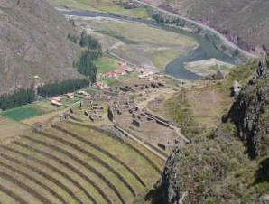
Arriving
Thursday April 22nd

This first day we will set up in the lodge and have the whole day to acclimatize rest and get ready for our retreat.

10:00am: Transportation from Cusco (airport or hotel if you have arrived early) to Tierra Nuna Ayni center in the Sacred Valley (around 1 hour drive from the airport). Let us know in advanced your flight or Hotel name to susana@nunaayni.org

1:00 pm Lunch

4:00 pm Welcome Circle. Sacred fire. We will share the overall vision of this sacred retreat and our intentions for this journey.

7:00 pm Dinner

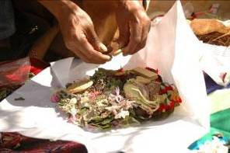
Remembering and Connecting
Friday April 23rd

8:00 am Breakfast

10:30 am Introductory talk: Andean Cosmovision and Huachuma by Luz Maria Ampuero

1:00 pm Lunch

4:00 pm Offering to Pachamama with the Q´ero Nation brothers. The Q’eros are one of the most ancestral keepers of the Andean traditions and the ones that reveal the Prophecy of the Eagle and the Condor to the world. Offering our prayers. Starting the healing process.

6:00 pm Dinner

Healing and Praying: Wachuma Ceremony
Saturday April 24th

8:00 am Wachuma ceremony with Luz María Ampuero and the assistance of Fer Pal. Wachuma is a sacred medicine plant from the Andes that allow us to heal and open our hearts to connect with mother Earth and all our relations.
We will do our sacred medicine plant ceremony at the Wachuma Temple.

6:00 pm Dinner

* Read more about Luz Maria and Fer Pal at the end of the program.

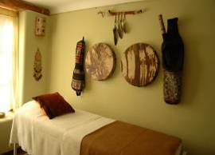
Relaxing and Integrating
Sunday April 25th

8:00 am Breakfast

10:00 am Circle of tobacco and sharing of the experience

1:00 pm Lunch

3:00 pm Personal consultation and Individual Massage

7:00 pm Dinner

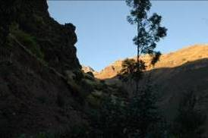
Resting
Monday April 26th

8:00 am Breakfast

Free Time

1:00 pm Lunch

Free Time

7:00 pm Dinner

*Individual appointments will be schedule during this time to talk about intentions for the next medicine ceremony.

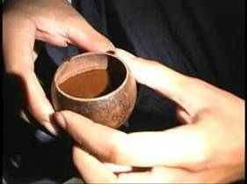
Purification and Healing Ceremony
Tuesday April 27th

8:00 am Light Breakfast

11:00 am Talk about the healing process with Ayahuasca.

5:30 pm Gathering at the Ayahuasca temple

6:00 pm Ayahuasca Ceremony with Luz María Ampuero and the assistance of Fer Pal at the Ayahuasca Temple.

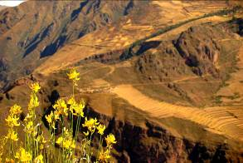
Relaxing and Integrating
Wednesday April 28th

11:00 am Circle of tobacco and sharing of the experience

12:00 pm Brunch

2:00 pm Personal Consultation

7:00 pm Dinner
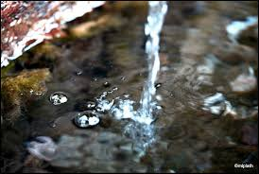
Therapeutic Bath
Thursday April 29th

8:00 am Breakfast

9:30 am Departure to Calca to Mama Tere’s Sanctuary where we will be having the therapeutic bath. Read more about Mama Tere at the end of the program.

10:00 am Bath with medicinal plants for cleansing and relaxation with Mama
Tere. Individual session.

1:00 pm Lunch

3:00 pm Bath with medicinal plants for cleansing and relaxation with Mama
Tere. Individual session.

7:00 pm Dinner

8:00 pm Departure to Pisaq.

*Individual appointments will be schedule during this time to talk about intentions for the next medicine ceremony.

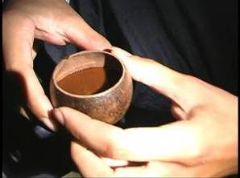
Purification and Healing Ceremony
Friday April 30th

8:00 am Light Breakfast
6:00 pm Ayahuasca Ceremony with Luz María and the assistance of Fer Pal. at the Ayahuasca Temple.

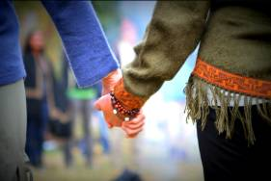
Integration Time
Saturday May 1st

11:00 am Circle of tobacco and sharing of the experience

12:00 pm Brunch

2:00 pm Personal Consultation

6:00 pm Dinner

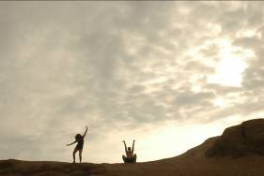
Dance Movement Session
Sunday May 2nd

8:00 am Breakfast

10:00 am Dance Movement session with Luz Maria.

1:00 pm Lunch

7:00 pm Dinner

Closing Wachuma Ceremony
Monday May 3rd

8:00 am Wachuma ceremony with Luz María Ampuero and the assistance of Fer Pal.
We will do our sacred medicine plant ceremony at the Wachuma Temple.

6:00 pm Dinner

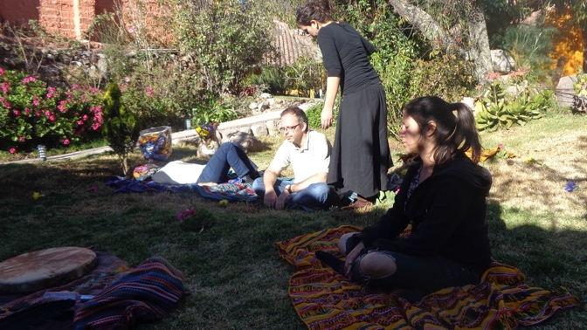
Integration Sound healing
Tuesday May 4th

8:00 am Breakfast

10:00 am Circle of tobacco and sharing of the experience

1:00 pm Lunch

4:00 pm Sound healing with Luz Maria. (Or maybe Tito La Rosa as a special gift for being the first retreat!)

7:00 pm Dinner

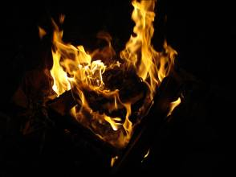
Goodbye Ceremony
Wednesday May 5th

8:00 am Breakfast

Free Time

1:00 pm Lunch in Doña Clorinda famous restaurant in Pisaq

5:00 pm Goodbye Ceremony. Sacred Fire. Final integration work.

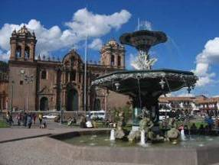
Depature to Cusco
Thursday May 6th

8:00 am Breakfast

11:00 am transportation to Cusco Hotels and Airport.

Therapists and Staff

Luz Maria Ampuero (Perú)

Luz Maria is one of the Founding Directors of Nuna Ayni. She has been learning and working in the field of Peruvian ancestral medicines since 2001. She has participated in global events promoting peace and ecological sustainability. Since 1998 she is working with dance and movement. Since 2003, Luz Maria has traveled internationally conducting various workshops and therapies, including Andean ceremonies and rituals, medicinal plants and herbs, women’s workshops, reiki, reflexotherapy, and massage. She dedicates her life to keep sharing the Nuna Ayni vision and the wisdom of our ancestors and how to live in harmony with oneself as well as one’s surroundings.

Mama Tere (Perú)

Teresa, known as Mama Tere, is a medicine woman who works with different ceremonies and rituals from the Americas and the world. She specializes in the soul of every living being and works with mother earth, animals and people from all ages. In her place, where she lives, she receives people from all around the world where she shares her medicine of love through ancestral traditions of healing, sacred fire, baths, massages, therapeutic talks and consultation, tarot readings, nutritional food, energetic cleansing, among other amazing spiritual work.

SARAH BAMFORD SEIDELMANN M.D.

She was a fourth generation physician living a nature-starved, hectic lifestyle until a walrus entered her life and changed everything. She’s a practicing shamanic healer and leads transformational travel retreats around the world. She’s the author of The Book of Beasties: Your A-Z Guide to the Illuminating Wisdom of Spirit Animals (Sounds True 2018), Swimming with Elephants (Conari Press, 2017) and Born to FREAK: A Salty Primer for Irrepressible Humans (2012). She has been a grateful student of the sacred plant medicines since 2015.
followyourfeelgood.com

Susana Tello (Perú)
She has 40 years of experience in the Peruvian labor system in the administration area. She worked at the Universidad de Lima for 15 years as an administrative assistant in the faculties of Industrial Engineering and Systems Engineering, Vice Rector’s Office and the Investigation Department. The last 9 years she was the manager assistant of the Director for the company Haskoning International DHB Sucursal Peru. Today she works for the organization Nuna Ayni as a project coordinator and executive manager for fundraising.

Charito

She is our wonderful and special cook that has more than 35 years cooking special Peruvian dishes. Since 2017 she has being specializing in different types of healthy food such as vegetarian, vegan, gluten free and lactose free. She has been working in the kitchen for all the retreats in Nuna Ayni and delighting everyone with her amazing seasoning and flavor.

Meals

During all this week you will receive a special diet for all the ceremonies and rituals based on vegetarian organic Andean food.

Accommodation and Logistics

We will accommodate our groups in the Tierra Nuna Ayni Center! Our center is 15 minutes away drive from Pisaq town and one hour and a half walking. From Arpil 22nd to May 6th you will stay in the Sacred Valley of Cusco in our recently build Center.

- Please send your itinerary flight or name of your hotel in Cusco to Susana at susanatello28@hotmail.com. She will be arranging all the logistics for us during our time in June. Please send her all your details as she will be arranging the transportation and coming to pick you up. REMEMBER you have to arrive before 10:00 am if you are arriving on the 22nd of April, as transportation will be leaving Cusco around this time to bring you all to Tierra Nuna Ayni, where we will be having our program.
- For the days of our retreat we will live a community experience at our place which have shared rooms and shared bathrooms. If you have any preference to who you will like to share the room with, please give that information to Susana too when you send her your info of arrival in Cusco. Also, if you are open and don't have any preference, mention this in your email. Thank you for your collaboration.
- During all this time together, you will receive a special diet for all the ceremonies and rituals based on vegetarian and most of it organic Andean food. Please if you have any food allergy, also include this information to Susana.
- We ask you to please bring with you your earplugs, as some days because of the effects of the medicine you will be more sensitive in your senses, so please get prepare in case any kind of noise can disturb you.
- The accommodation in our center is basic and design to be in the simplicity we need to do our work. We have beautiful gardens and areas to meditate, rest and hang out, a shared kitchen and areas to practice yoga or any other exercise practice.
The staff that will be taking care of you during your time here is Susana at logistics, Charito cooking the meals for us and Luz Maria with ceremonies and Rituals. So please from now on any logistic question you have or arrangement you need please contact Susana at susanatello28@hotmail.com. Also remember to read all the general information here in the program itinerary.
Price

The cost of the program is US$ 2700 per person. Before June 1st we give you a $300 discount. The price includes all the meals, accommodation, transportation (including transportation available during our retreat to go to Pisaq town), touristic sites, individual therapies, talks, activities, ceremonies and all the materials of the program from April 22nd to May 6th. It doesn’t include plane tickets.

- The building of the first stage of our center, so that we could be able to host our people in our land, had been possible with the support and help of friends that were able to loan us the money we needed for the construction. A percentage of all donations collected for this program will help also Nuna Ayni organization to pay back the loan. Thank you very much for your support.
- Bring some extra for tips, extra activities and beautiful things you will like to buy.

* This is what we are asking for to be able to cover all the expenses and to support Nuna Ayni. If for any reason you have any inconvenient to pay and you really need this healing, please contact us we are willing to make this experience possible for you!

Capacity and Confirmation date

The program has been designed for a maximum of 10 people. If you are interested in participating and joining us in this unique experience, we are asking for the deposit of US$600 (non-refundable) before February 1st of 2021 and the application form that you will find at the end of all this information. Please don’t forget to send it to Luz Maria at luzmaria@nunaayni.org.pe first before making your deposit as you need to be approved by her. The deposit will be collected by Sarah so please contact her at sarahseidelmann@gmail.com. The remaining balance can be paid in cash at the arrival. Please make sure, if you are bringing cash that your dollar bills don’t have any rips or damage as they are not accepted in Perú.

*Please confirm your reservation and deposit.

Recommendations
- Bring layered clothing to prepare for sunny days and cold evenings.
- Boots or shoes for mountain hikes. Sandals for sunny days.
- Sun block cream, water bottle and hat.
- Journal and pen.
GENERAL INFORMATION
Water and Food
Tap water can be drunk in most parts of Peru but the chemical content is different in each place. To avoid problems we recommend that you drink only bottled water.
Peruvian cuisine is spicy and very varied. Although we recommend you to try the local and international cuisine available in Peru, which is known throughout the world as some of the best, we would also say that the main fast food chains also have branches in Lima.
Climate and Clothing
The driest months in the highlands are June to October, though the weather in this area can vary considerably in a single day: very cold at night and in the early morning and hot at midday. It is advisable, here to use clothes that you can change easily. Sweaters / jumpers, jackets and long trousers are necessary. Daytime temperatures can vary between 60¼F/15¼C - 70¼F/20¼C and between 40¼F/4¼C - 50¼F/10¼C at night. If you are visiting the city of Cusco, for example, (3,400 mts. / 11,200 ft.) and go on an excursion to Machu Picchu (2,400 mts. / 8,000 ft.) you will leave in the early morning when it is very cold but the temperature when you arrive may be quite high, not only because of the time of day but because of the altitude. It rains from December to March so waterproof clothing is essential.
Safety
As in all the world's large cities, there is a high incidence of handbag snatching. We therefore recommend that you carry money and credit cards in a money belt and don't take a handbag unless it is absolutely essential.
The main hotels have safe deposit boxes and we suggest you leave your valuables, passport and air tickets there. Be very careful with handbags, cameras and video recorders, especially in places where lots of people congregate, such as markets, railway stations and public squares, etc.
Time
Peruvian time is GMT -5 hours.
Currency
The Peruvian currency is the nuevo sol (S/.) It is a decimal system like almost everywhere else (100 centimos = 1 nuevo sol). Coins = 10, 20 & 50 centimos, 1, 2 and 5 nuevos soles; bank note denominations are 10, 20, 50, 100 and 200 nuevos soles.
The United States dollar exchange rate is variable. We suggest checking with in the internet or the bank. Try to keep small denomination to make transactions easier.
Most hotels, restaurants and businesses accept dollars but if you want to change your money into local currency we recommend you to do so at a bank or exchange houses. For your security, do not have anything to do with street money changers.
If you are bringing cash, make sure your dollar bills don’t have any rip and also make sure you don’t bring US$100 bills from the series CB B2.
There are automatic teller machines in strategic places where cash can be obtained using the principal international credit cards, either in Peruvian currency or in dollars. Take the usual security precautions when withdrawing cash from such machines. The best-known international credit cards (American Express, Diners Club, any Visa)
Electricity
220 volts AC / 60 Hz throughout Peru.
Transport
Cusco have a large number of taxis whose fares are very modest. Before taking a taxi we recommend finding out the approximate fares for your route.
Taxis have no meters, so before starting your journey agree the fare with the driver. Remember to carry coins to pay the fare.
Shopping
A large variety of silverware, alpaca and vicuña woollen goods and garments in pima cotton can be bought.
Our handicrafts are very varied and highly prized throughout the world.
Please remember that original antiquities ("huacos", ceramics, colonial-era paintings, Inca textiles and metal objects, etc.), which may be considered Peru's cultural heritage, cannot be taken out of the country.
Again, it is important to bear in mind where is your money finally going so always research who is making the goods you are buying and what percentage of the total cost are they receiving from your buy. Fair Trade practices are responsibility of all (producers, retail sellers and specially the buyers).
We hope you have a beautiful time in our sacred lands.
Urpillay Sonqollay!
Thank you from the deepest of our hearts!

APPLICATION FORM FOR MEDICINE PLANT RETREAT

This form has been designed to evaluate if this kind of experience will be beneficial for you as it is a very delicate and deep process.

Basic Information

Name: ______________________________________________________________________________

Age: _______________________________________________________________________________

Nationality: __________________________________________________________________________

Medical Condition
Please write a few lines about your medical, physical and psychological condition. If you are under any specific treatment, or taking any medication (including viagra if you are a man) please describe it. If not, go to the next question.

Intention
Please share your intentions for this retreat

Previous Experience

Have you ever had any experience with any kind of psychedelics before?
Yes No

Which ones? Give a short description

Me_______________ confirm that I have given all the information require here and that is true. I take all responsibility about my participation in this retreat.

