FOR IMMEDIATE RELEASE! Contact: Anthony J.W. Benson

Bang the Drum Communications bangthedrumcomm@gmail.com

HOW GOOD ARE YOU WILLING TO LET IT GET? THE NEW BOOK FROM SARAH BAMFORD SEIDELMANN M.D., WOMAN OF MEDICINE, SHAMANIC MENTOR AND AUTHOR OFFERS DAILY INSPIRATION AND WISDOM AND REVEALS WHAT VALUABLE INFORMATION OUR SPIRIT ANIMALS HAVE TO TEACH US. AVAILABLE JUNE 1, 2020.

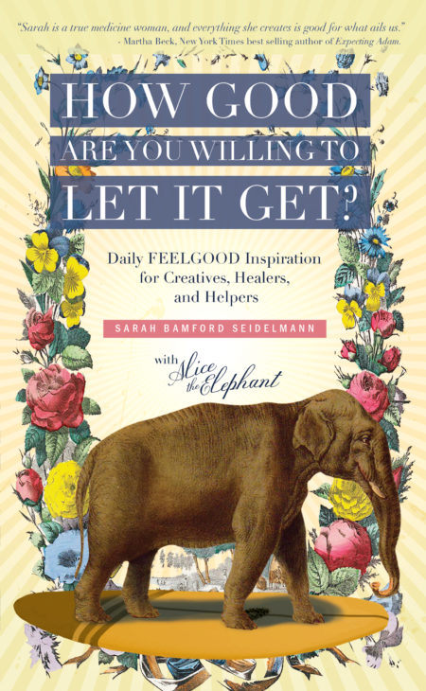
(Duluth, MN – May 6, 2020) Esteemed Woman of Medicine, Shamanic Mentor and Author, Sarah Bamford Seidelmann M.D. releases her highly anticipated fourth book HOW GOOD ARE YOU WILLING TO LET IT GET: Daily FEELGOOD Inspiration for Creatives, Healers, and Helpers. Available June 1, 2020, this life-affirming book focuses on daily doses of inspiration and wisdom from Sarah and her magnificent spirit animal, Alice, the Elephant.

Sarah and Alice created this book of inspiration to encourage creatives, healers, and helpers. Alice offers up daily wisdom in a lighthearted (and sometimes salty) way, and Sarah adds her reflections along with a prompt and prayer. Themes include Humility, Moderation, Self-love, Family, Friendship, Creativity, Pitfalls & Quagmires, Addiction & Recovery, Dealing with Fear.

Primed to help readers feel supported, inspired, and uplifted, this helpful book asks, “How good are YOU willing to let it get?” Sarah and Alice hope that your answer is “VERY good indeed!” and heartily believe this book will help you get there.

Seidelmann shares, “When I was in my early forties, I entered a midlife crisis as a physician. I came out the other side as a shamanic healer, a life coach (or as I prefer to refer to myself, a Life Obstacle Assassin), and a creative / writer. I decided to dedicate my life to doing work that creates health in myself and others. I’ve discovered a very special subset of people who are healers, artists, and helpers. We have magical powers, and we have unique challenges too. I wrote this book for all of us.”

Co-author Alice, the Elephant, adds, “As you hurtle toward your highest destiny, there will be trouble along the way. Naysayers, traffic jams, and times when you fall off the bike altogether. Climb back on, remember to ring that mother f%#ing bell on your handlebars, and keep pedaling! Invisible forces will buoy you.”

Sarah Bamford Seidelmann M.D. was a fourth-generation physician living a nature-starved, hectic lifestyle until a walrus entered her life and changed everything. She is a practicing Shamanic Mentor and Woman of Medicine and leads transformational travel retreats around the world. She’s also the author of the popular books, The Book of Beasties: with Your A-Z Guide to the Illuminating Wisdom of Spirit Animals (Sounds True 2018), Swimming with Elephants (Conari Press, 2017) and Born to FREAK: A Salty Primer for Irrepressible Humans (2012). Sarah resides in northern Minnesota, near Lake Superior with her family and two dogs.

Available on AMAZON and wherever books are sold • June 1, 2020, • Paperback $22.22 US

Interviews (subject to schedule and availability), review copies and hi-res photos are available upon request.
Please visit FollowYourFeelGood.com for more information.
Contact: Anthony J.W. Benson/Bang the Drum Communications
505-690-1052 • bangthedrumcomm@gmail.com
###

